Box Newsletter September 2019

Box Drive has been successfully rolled out to UCOP. This was the replacement for Box Sync and should make it much easier to work with all your files in Box and be more productive.

What is Box Drive?
Box Drive is a new desktop app from Box that allows you to access all your files in Box from your computer without needing to download or sync those files first.

Learn Box Drive basics.

Box classes are now in UC Learning Center
Come learn how you can maximize Box from a Subject Matter Expert. These classes are for all levels of expertise and are available to sign-up now. Next class: Thursday, Nov. 7.

Box for Office
We are looking for users to try Box for Office — an add-in to Microsoft Office applications that gives you direct access to your files in Box. Learn more. If you are interested please let the Service Desk know at servicedesk@ucop.edu.

Quick Box Tips
Quick Tip 1: Restore files
Did you accidentally delete a file or folder from your Box account? Don’t worry! Restore it from your Trash.
- Click on Trash on the left side of screen

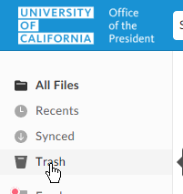

- Locate the file/folder and Click on the …

- Select Restore
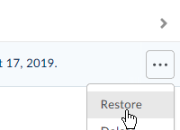

The file/folder will be restored to its original location.

Quick Tip 2: Best practices for setting up new folders for collaboration
Box uses waterfall permissions, so whatever permissions start at the top level trickle down to all subfolders. For best security and most flexibility, invite the fewest collaborators to upper-level folders (the ‘admins’ of the folder structure) and add people as you go down the folder structure.

Quick Tip 3: Box Groups
Consider using Box Groups if you have a large number of people you want to invite to a folder. This will help you avoid inviting individuals to folders and just using a defined Box group that has the whole department. Reach out to the Service Desk to request Box group creations.

Quick Tip 4: Box accounts of separated employees
If an employee stops working at UCOP, their Box account is deleted 45 days after their separation — including content they’ve shared with others. Separating employees should transfer their files to their manager or other users in the department prior to leaving UCOP. Access to an employee’s files after separation requires approval of the executive director of Local Human Resources.

Quick Tip 5: Try Box Notes
Box notes are great for capturing quick thoughts or creating lists. Plus:
- Notes can be shared like any other document on Box
- Notes can be created in or moved to any Box folder
- All Notes can be accessed from the Notes sidebar regardless of their folder location
Try it!
Create a quick Note from within any folder by clicking the icon at the top of the page
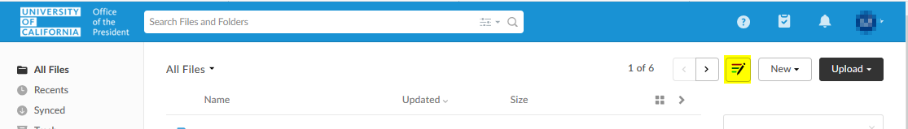
Box Notes has templates for Meetings, Projects, Newsletters and more!
To use a Box Notes Template, click New > Note from template
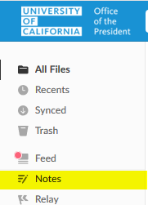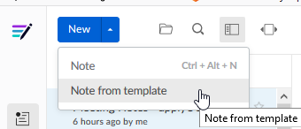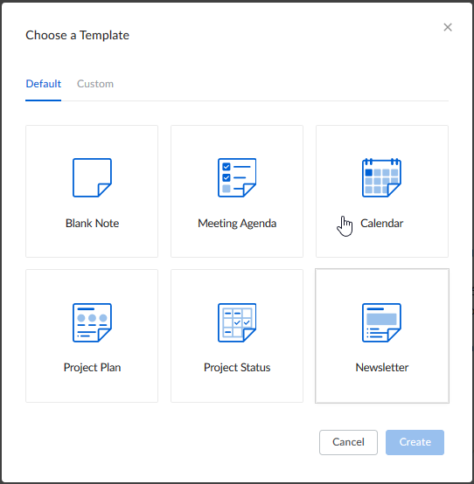
Also, you can create your own templates from previous Notes. The new template can be accessed from the “Custom” Template tab
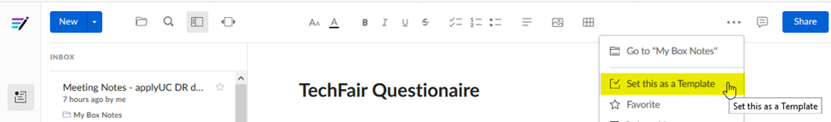

Quick Tip 6: Try Bookmarks
You can create a Bookmark in any Box folder to save any webpage to Box as a bookmark (including content for which you only have "viewer" permissions), helping you organize and quickly access the web-based content you visit most often.
To create a bookmark:
Click the New button found in the upper-right corner of the page. Select Bookmark. 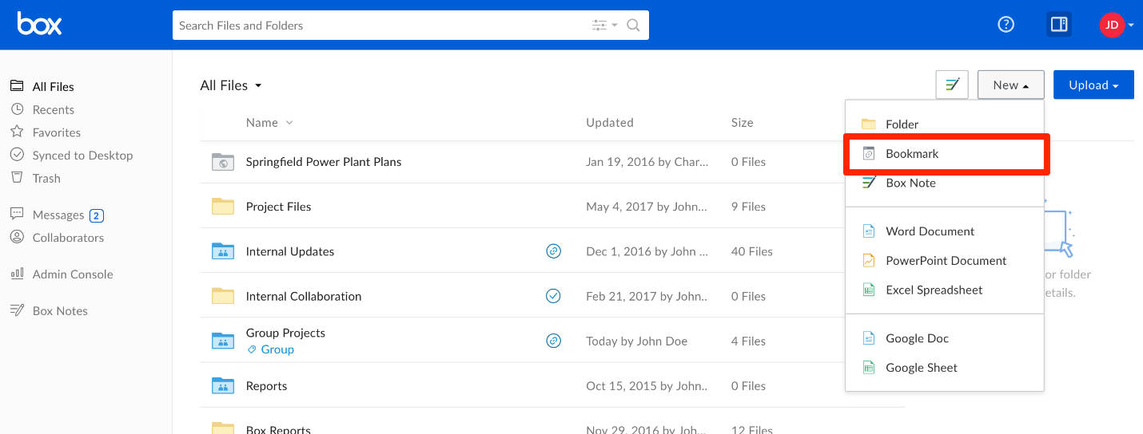
A pop-up window will appear prompting you to enter the URL you wish to bookmark (ex. the shared link for a Box folder that you have at least “viewer” permissions to), and a name for your new bookmark. A description is optional.
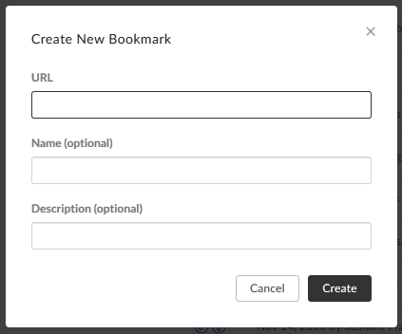
Click Create to complete the process.
Your bookmark will appear in the folder you are currently viewing. Clicking it will open the page in a new tab.
Limitations:
- Bookmarks cannot be synced as Box Sync and Box Drive ignore web-based documents.
- The bookmarked URL cannot exceed 500 characters.

Additional resources

- The Box User Guide in the Getting Started Folder contains easy-to-use directions in case you need a quick reference.
- Take advantage of Box University for useful tips and training courses!
- As always, please contact the UCOP Service Desk at servicedesk@ucop.edu for any questions with Box.

