Alison King, LCSW

Health Net/MHN

Friday, June 4th, 12:00-1:00pm

**via Zoom** 408.638.0968 Meeting ID: 510.987.9837  
<https://UCOP.zoom.us/j/5109879837?pwd=NStta2R3ZFl6NnJBeldrejFjU1pMdz09>

From lockdowns, to masks and social distancing, to mass vaccinations and an ever-changing landscape of guidelines, the concept of “normal” has become fluid and elusive, and realistically, life may never return to the way it was. For some of us, this new normal calls for acrobatics – work, kids and hybrid learning, keeping the household afloat…and now, adding on trying to re-engage in life outside the home circus tent. For others, it might not be so chaotic, but we may be feeling lonely, unmotivated, and purposeless, especially as the hope of a return to our old ways of life begins to wane. The common denominator is disequilibrium which requires all of us to learn how to continually re-calibrate - daily or sometimes even moment-to-moment. The goal of this presentation is to provide concrete ways to build resilience and endurance, with a focus on our whole self, so we can create a more consistent homeostasis.

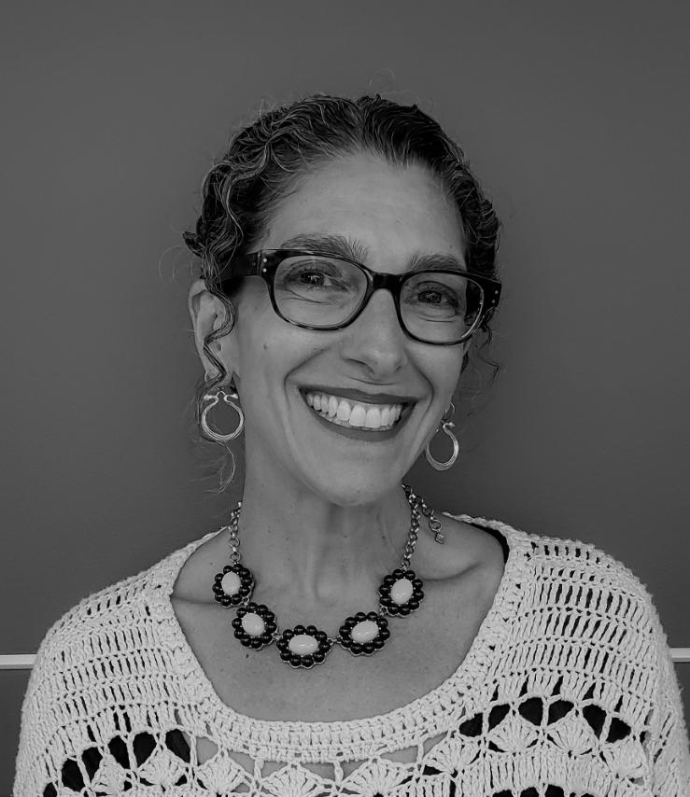

Adjusting to the New Normal: Resilience, Endurance, and Whole Person Self-Care

The President's Advisory Committee on the Status of Women *presents:*

HEALTH & WELLNESS BROWN BAG SERIES

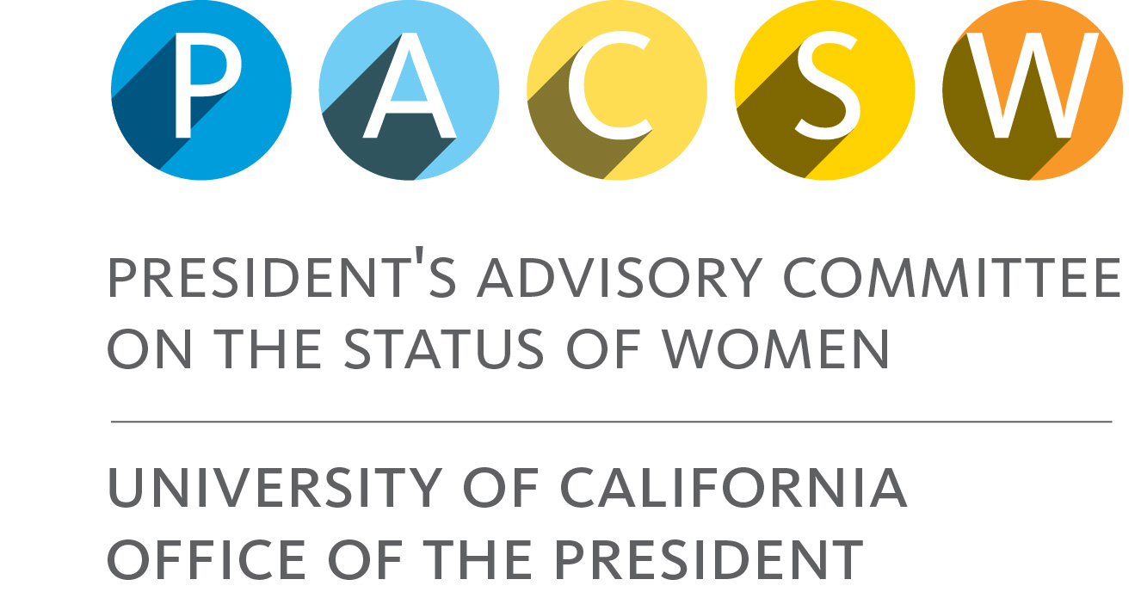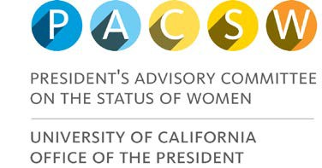

*Questions? Gale Sheean-Remotto, Gale.Sheean-Remotto@ucop.edu*

*The President’s Advisory Committee on the Status of Women (PACSW) advances an agenda to improve the climate and opportunities for women at UCOP. Learn more at* [*http://ucop.edu/pacsw/.*](http://ucop.edu/pacsw/)

* UC bullet

UC series name

UC sub time/place

UC sub date

UC sub head

UC body

UC head

UC head 43

UC sub body