**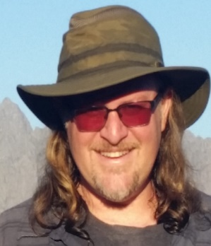***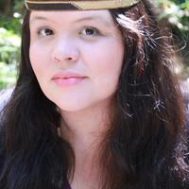*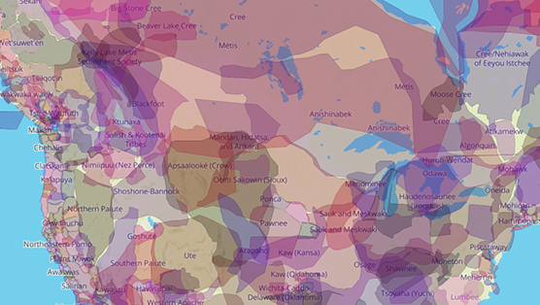

**Dr. Cutcha Risling Baldy** is Associate Professor and Department Chair of Native American Studies at Humboldt State University. Her research is focused on Indigenous feminisms, California Indians and decolonization. She received her Ph.D. in Native American Studies with a Designated Emphasis in Feminist Theory and Research from the University of California, Davis. She is also the author of a popular blog that explores issues of social justice, history and California Indian politics and culture [www.cutcharislingbaldy.com/blog](http://www.cutcharislingbaldy.com/blog). She is Hupa, Yurok and Karuk and an enrolled member of the Hoopa Valley Tribe in Northern California.

**Dr. Wallace Cleaves** is Associate Professor of Teaching and Associate Director of the University Writing Program at the University of California at Riverside. He has taught courses in Medieval, Renaissance, and Native American literature at Pomona College, Cal State Fullerton, and at UC Riverside. He received his Ph.D. in Medieval English Literature at the University of California at Riverside. He is a member of the Gabrielino / Tongva Native American tribe, the indigenous peoples of the Los Angeles area, and is heavily involved with his tribe, having served on the Tribal Council and currently working on the development of a Land Trust.

*The Native American, Indigenous and Pacific Islander Staff Association (NAIPISA)*

*Presents:*

**Indigenous Land Acknowledgements:**

**Why They Matter and Why They Are Not Enough**

November 1, 2021 (11:00 AM – 12:00 PM)

**To Register:**  <https://UCOP.zoom.us/meeting/register/tJUldOGuqzMtH9dWJn_qMknl8rliflvGUow2>

**Department:** Native American Indigenous Pacific Islander Staff Association (NAIPISA)

**Event contact:** Tae-Sun Ki

**The Native American, Indigenous and Pacific Islander Staff Association (NAIPISA) welcomes two members of the UC President’s Native American Advisory Council to present on land acknowledgement statements, and to offer guidance on writing and delivering land acknowledgments as a practice for deepening understanding and bringing about justice for indigenous communities.**

Contact: NAIPISA@UCOP.EDU