Wednesday, April 13, 2022
UCOP Asian Pacific Islander Staff Association*
Panel Discussion: AAPIs in UC Leadership — Challenges and Opportunities
12:00 to 1:30 p.m. (PT)
Note: This event will be recorded.

Zoom: https://UCOP.zoom.us/j/5336808316
- Dial: (669) 900-6833
- Meeting ID: 533 680 8316

Questions about this event?
Please contact Tony.Yang@ucop.edu or Benjamin.Tsai@ucop.edu.

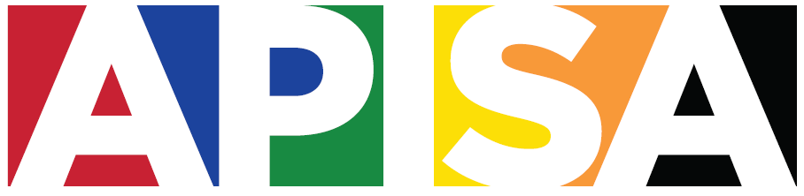

Come join our distinguished panelists for a conversation about the under-representation of Asian-Americans and Pacific-Islanders in leadership positions at UC and potential solutions to this challenge. Featured speakers include:
- UC bullet
UC series name
UC sub time/place
UC sub date
UC sub head
UC body
UC head
UC head 43
UC sub body
- Priya Lakireddey, Staff Advisor to the Regents – Designate
- Patricia Nguyễn, Director, Systemwide Alumni Engagement
- Robert Teranishi, Professor of Social Science and Comparative Education, Morgan and Helen Chu Endowed Chair in Asian American Studies, UCLA
- Lucy Tseng, Staff Advisor to the Regents

