RSS Computer Ergonomics
Self-Assessment

Login to RSS Computer Ergonomics
Log in using your campus credentials and select the Computer Ergonomics Self-Assessment icon

Create a new Self-Assessment as the Owner
- Select the Start New Assessment Icon to start a Self-Assessment

- Assessment should start in Draft Status

- Select continue to go to the assessment section to complete the assessment form
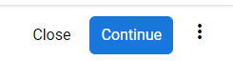

- Summary page shows user’s progress and Assessment sections
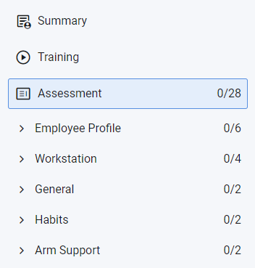

Submit Self-Assessment
- Answer the Self-Assessment questions
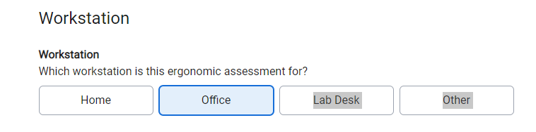

- Progress bar will update when questions are answered

- Outcomes will be provided when questions are answered. If there is required training for the outcome there will be a link that takes you to the training.
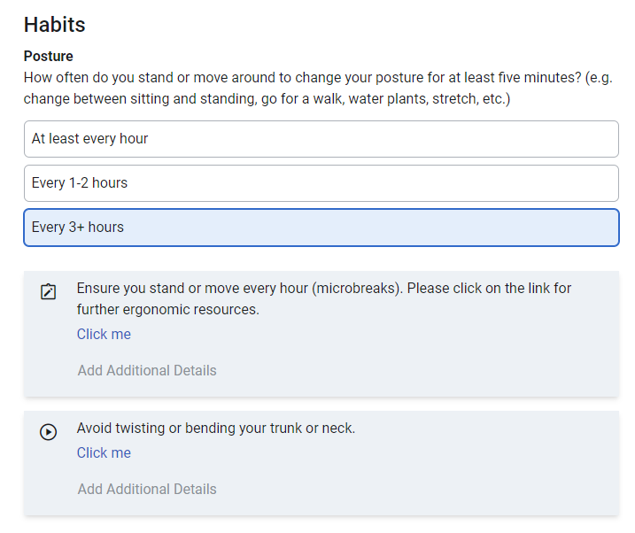

- Questions counts will update after each question is answered
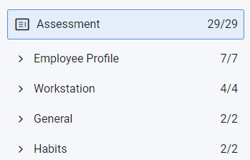

- After all required questions are answered select the Submit Icon

