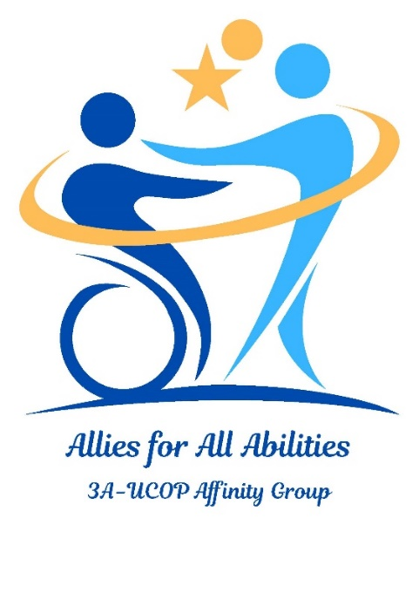

**UCOP Allies for All Abilities (3A) Affinity Group**

**is pleased to present:**

**Disability Etiquette and Language**

**with Sarah Houghton**

Sarah Houghton is a UCOP 3A Affinity Group co-founder and the Director of Discovery and Delivery for the California Digital Library at UCOP. She has been a disability advocate since childhood and a librarian specializing in technology leadership and administration for 25 years.

**Date**: Monday, September 23, 2024

**Time**: 12:00 – 1:00 PM

**Venue**: Zoom: <https://UCOP.zoom.us/j/99325111998>

For additional information, don't hesitate to get in touch with [Belinda.Vea@ucop.edu](mailto:Belinda.Vea@ucop.edu) OR [Sarah.Houghton@ucop.edu](mailto:Sarah.Houghton@ucop.edu)