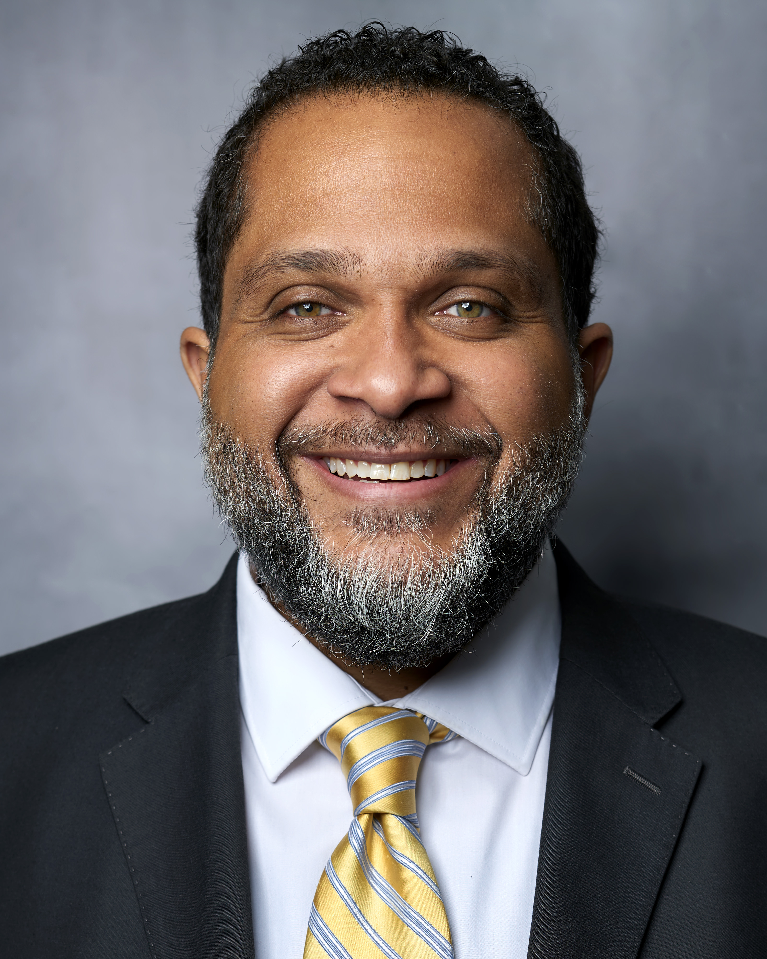What:

UCOP Pride Brown Bag Lunch with ERG Sponsors

UCOP Pride Employee Resource Group

Brown Bag Lunch

When:

**Tuesday, September 10, 2024**

12:00 – 1:00 p.m.

Where:

**UCOP Franklin**

5th Floor Rooftop Garden

Please join UCOP Pride and ERG Executive Sponsors Pamela Brown and Paul Williams for an informal brown bag lunch.

* UC bullet

UC series name

UC sub time/place

UC sub date

UC sub head

UC body

UC head

UC head 43

UC sub body

Bring your lunch (or just yourself) and come meet our ERG sponsors and connect with fellow UCOP Pride members as we bask in recent successes and discuss new ways to support the LGBTQ+ community at UCOP and beyond. All are welcome!