Learn more about *Toastmasters*. We bring you affordable communication and leadership training in a friendly and supportive environment.



**Join Us!**

**~**

Lakeside Speakeasy Toastmasters Club

Presents…

**Hybrid Open House**

**with Treats from Mr. Espresso!**

**~**

Wednesday, January 29 12:05pm – 12:55pm

**10001 Broadway Building**

(In-Person and on Zoom)

**RSVP to** [**lakesidespeakeasy@gmail.com**](mailto:lakesidespeakeasy@gmail.com)

[**www.2967toastmastersclubs.org**](http://www.2967toastmastersclubs.org/)

**Learn what Toastmasters is all about!**





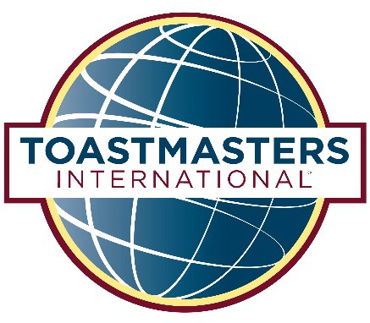

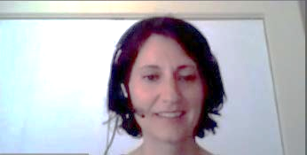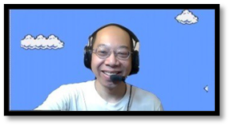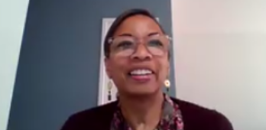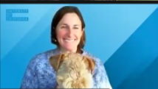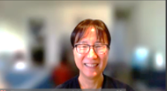

**Uncover your Leadership Potential**

Find your inner leader with Toastmasters. Learn how to speak in front of a group with confidence and work with others in a positive, supportive environment. Let us help you advance your career and discover new opportunities.

**Participating in Toastmasters gives you powerful tools to get ahead:**

* Build strong leadership skills
* Practice public speaking and presentation skills
* Gain self-confidence
* Boost your ability to collaborate and inspire

**WHERE LEADERS ARE MADE**