Learn more about Toastmasters. We bring you affordable communication and leadership training in a friendly and supportive environment.


Join Us!
~
Lakeside Speakeasy Toastmasters Club
Presents…
Hybrid Open House
with Food and Beverages
~
Wednesday, April 1st 12:05pm – 12:55pm

10001 Broadway Building
(In-Person and on Zoom)
RSVP to lakesidespeakeasy@gmail.com
www.2967toastmastersclubs.org

Confidence and Communications Skills



One speech (and one slice) at a Time!

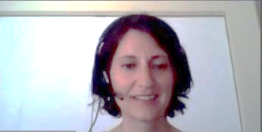

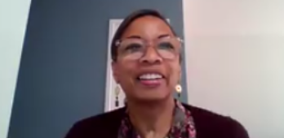

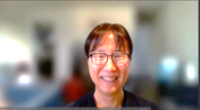



Uncover your Leadership Potential
Find your inner leader with Toastmasters. Learn how to speak in front of a group with confidence and work with others in a positive, supportive environment. Let us help you advance your career and discover new opportunities.

Participating in Toastmasters gives you powerful tools to get ahead:
- Build strong leadership skills
- Practice public speaking and presentation skills
- Gain self-confidence
- Boost your ability to collaborate and inspire
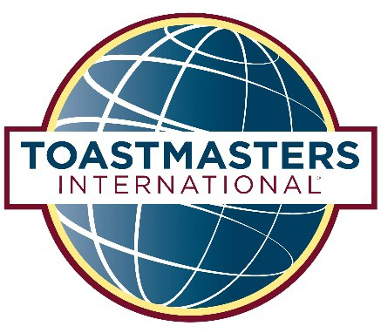

WHERE LEADERS ARE MADE



